Boniface Musyoki

Technical Interview Assessment Report

1. Manual Testing

(Test cases for the login functionality and other features of the web application).

Test Case Design
Pay attention to the login functionality, covering both positive and negative scenarios:
- Positive Scenario: Valid login credentials
- Negative Scenario: Invalid login credentials, empty fields,
Test Case ID | Description | Steps | Expected Result
TC1 | Verify successful registration of a new user with valid credentials. | - Go to (“http://localhost/New-Web-App/index.php”) site.  - Click on the sign up link.  - Enter valid credentials (name, email, password, confirm password).  - Click on the “Sign up” button | A message "Signup successful. You can now log in.” A new user should be registered and can successfully log in.
TC2 | Verify registration of a new user with invalid credentials | - Go to (“http://localhost/New-Web-App/index.php”) site.  - Click on the sign up link.  - Enter invalid credentials (name, email, password, confirm password).  - Click on the “Sign up” button | Error messages of name, email, and password are shown in order of their rules.
TC3 | Verify successful login with valid credentials | - Go to (“http://localhost/New-Web-App/index.php”) site.  - Navigate to the login page.  - Enter valid name and password  - Click the "Log in" button. | User is successfully logged in and redirected to the Home page.
TC4 | Verify login fails with invalid credentials | - Go to (“http://localhost/New-Web-App/index.php”) site.  - Navigate to the login page.  - Enter invalid name and password  - Click the "Log in" button. | Error message “Invalid login” is displayed indicating login failure.
TC5 | Verify login fails when fields are left empty (Invalid login) | - Go to (“http://localhost/New-Web-App/index.php”) site.  - Navigate to the login page  - Leave name and password fields blank  - Click the "Log in" button. | Error message “Invalid login” is displayed indicating login failure.
TC6 | Verify page refresh issue on valid login | - Go to (“http://localhost/New-Web-App/index.php”) site.  - Navigate to the login page  - Leave username and password fields blank  - Click the "Log in" button. | The page refreshes without logging in the user.(Bug scenario)
TC7 | Verify user can navigate to (Album,Users, Photos) page and redirect back to home page | - Go to (“http://localhost/New-Web-App/index.php”) site.  - Navigate to ((Album,Users, Photos) page in a respective manner.  - Click on “Home” link at the bottom of each page. | Uer should be able to visit the (Album,Users, Photos) page and redirect back to the home page,

Bug Report

Bug ID: BUG001
Description: Page refreshes without logging in after entering valid credentials.
Severity: High
Steps to Reproduce:
- Go to (“http://localhost/New-Web-App/index.php”) site.
- Navigate to the login page.
- Enter valid credentials (valid name and password).
- Click the "Log in” button.
Expected Result: User should be logged in and redirected to the Home page.
Actual Result: The page refreshes, but the user remains on the login page without being authenticated.
Attachment:
https://app.screencast.com/nBiVcpxAIXfaw?conversation=nhovY5OFyYobowl5wcOw5i

2. Test Automation
Test script to automate the search functionality (JavaScript with Cypress):
cypress

describe('Search Functionality', () => {
it('should return correct results when searching for an album', () => {
cy.visit('http://localhost/New-Web-App/Album.php' );
cy.get('#searchInput').should('be.visible');
cy.get('#searchInput"]').type('Album Title');
cy.get('button[type="submit"]').click();
cy.get('.album-list').should('contain', 'Album Title');
});
it('no result listed if album is not found', () => {
cy.get('#searchInput').type('non-existing album”');
cy.get('#photoContainer').should('contain', 'no album');
});
});

3. API Testing
Use Postman for API testing( /users, /albums, and /photos endpoints):

3.1 Positive Scenario

API Endpoint | Test Case Description | Request Type | Expected Response
/albums | Verify retrieving the list of albums | GET | Status code 200 ok , Response body contains a list of album details.
/photos | Verify retrieving the list of photos | GET | Status code 200 ok, Response body contains a list of photo details.
/users | Verify retrieving the list of users | GET | Status code 200 ok, Response body contains a list of user details.
/users/{id} | Verify retrieving a user by ID | GET | Status code 200 ok, Response body contains the details of the user.
/albums/{id}/photos | Verify retrieving the photos for a specific album | GET | Status code 200 ok, Response body contains a list of photo objects.

3.2 Negative Scenario(Test Cases)

API Endpoint | Test Case Description | Steps | Request Type | Expected Response
/albums | Verify handling of invalid album data | - Send a POST request to /api/album with an invalid payload (e.g., missing title).  - Verify the response status code is 400.  - Confirm the response body contains an appropriate error message. | POST | Status code 400, Error message
/photos | Verify handling of invalid photo data. | - Send a POST request to /api/photo with an invalid payload (e.g., missing image file)  - Verify the response status code is 400.  - Confirm the response body contains an appropriate error message | POST | status code is 400, Error message
/users | Verify handling of unauthorized access | - Send a GET request to /api/users without an authorization token.  - Verify the response status code is 401.  - Confirm the response body contains an appropriate error message. | GET | status code is 401, Error message

4. Performance Testing
Use JMeter:

Load Testing:
1000 users can access the site simultaneously with a ramp-up time of 10 seconds looping 10 times in 39 seconds while visiting several features of the web app.
The site remains responsive and does not crash
https://app.screencast.com/eQOZ9ddw8VIww?conversation=1WatTGeWScFjUbcC5kD5mf

Stress Testing:
Gradually increased the number of users beyond 1000 to find the breaking point. The results are well displayed in the screenshot and video attachment.
https://app.screencast.com/tcxr8yVqkfm4H?conversation=Hy2Vx4hNw1MtJYahqZbM1i
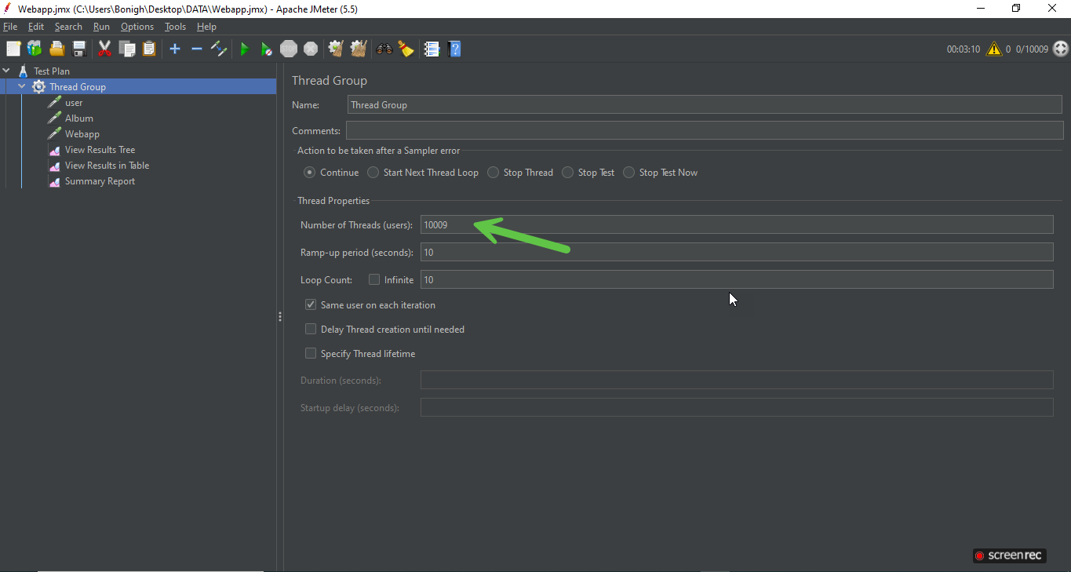

Response Time Testing:
The application responses on navigating to user, album, and home page. Results for response time, latency and error rate are displayed in the screenshot and video attachment.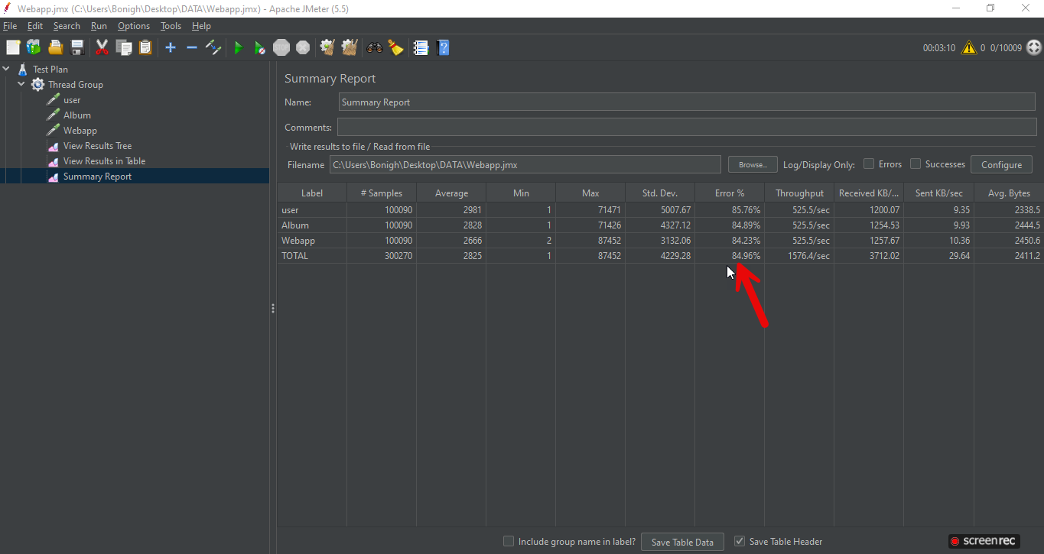
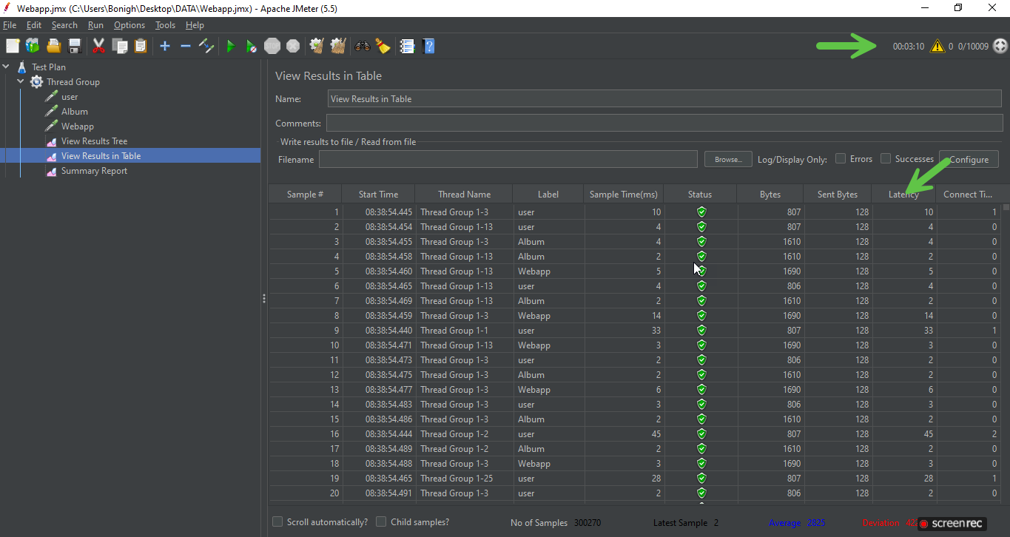
https://app.screencast.com/tcxr8yVqkfm4H?conversation=Hy2Vx4hNw1MtJYahqZbM1i

